PAS701 Summer 2019 Exam 2 Study Guide: Upper Limb and Thorax
Practical portion: 1:00-2:15pm in the MDL
- The practical portion will consist of 50 identification tags on gross structures, bones, and radiology.
  - The radiology images will be chosen from the pool of images that are included at the end of this document.
  - We reserve the right to use images from Dr. French’s radiology presentation as well.
  - There will be two radiology images on the practical with four questions (each worth half of a point).
- Be able to identify bolded and italicized structures in the dissector.
- For bony landmarks, the dissector is not exhaustive, so be sure to utilize lecture PowerPoints for additional landmarks, particularly those that were emphasized for muscle or ligamentous attachment.
Written portion: 2:30-5:00pm in C1847
- The written portion will be composed of 10 essay questions (10 points possible per question) answered in sentences (no lists, bullets, or charts).
- We recommend that you spend about 15 minutes per question during the exam.
- Utilize this list of questions below to guide your studies for the written portion.
- Note: questions that appear on your exam may not be “verbatim” to the list below, but they will be identical in concept.
Lecture 16: Introduction to the Upper Limb, Dr. Evey
- Regional anesthesia of the shoulder joint requires blocking the suprascapular nerve in the supraspinous fossa. Review the anatomy and relationships of the superior transverse scapular ligament.
Lecture 17: Shoulder, Scapular Region, and Posterior Arm, Anna
- A 66-year-old woman had a radical breast mastectomy to treat her breast cancer. Radical breast mastectomy may cause “winging” of the scapula. Discuss the nerve and muscle that, when disrupted, cause winging of the scapula. In your discussion be sure to include muscular attachments, function, innervation, vasculature, and lymphatics.
- A 22-year-old woman comes to your clinic reporting inability to fully abduct her upper limb above her head. Abduction of the upper limb from 0 to 180 degrees above the head requires recruitment of four muscles served by four nerves. Discuss the ranges of movement provided by the muscles and the nerves that allow for full abduction of the upper limb. In your discussion include muscle functions, innervation, and vasculature.
- A 44-year-old male patient presents with a swelling in the posterior shoulder and paresthesia to the superolateral arm. Upon examination you determine there is a cyst in the quadrangular space. Discuss the boundaries and structures passing through the quadrangular space.
Lecture 18: Pectoral Region and Breast Anatomy, Claire
- A 55-year-old female was diagnosed with stage four breast cancer. Explain anatomically how breast cancer of the right breast can spread to the left breast. In your response discuss the tissue structure of the breast, vascular supply, nerve supply, surrounding musculature, and lymphatic drainage of the right and left​ breast.

- A 55-year-old female was diagnosed with stage four breast cancer. Explain anatomically how breast cancer can spread from breast tissue into the lung tissue. In your response discuss the tissue structure of the breast, vascular supply, nerve supply, surrounding musculature, and the lymphatic drainage associated with the breast.
Lecture 19: Axilla, Natalie
- A surgeon ligates the axillary artery to repair a ruptured aneurysm. Describe the anatomy of the axillary artery with respect to the scapular and shoulder anastomosis. Describe the flow of blood if the surgeon ligates the axillary artery (1) distal to the thyrocervical trunk and proximal to the subscapular artery (2) distal to the subscapular artery and proximal to profunda brachii. What would the effect be on the perfusion of the 5th digit during the surgical intervention for each case?
Lecture 20: Brachial Plexus, Dave
- A 42-year-old cowboy reports to your clinic after being thrown from his horse. His chief concerns are weakness of his upper limb, accompanied by numbness in his superolateral arm and his lateral forearm. At rest, his affected side assumes a “waiter’s tip position,” (flexed wrist) in which his arm is adducted and medially rotated, with an extended elbow. Discuss the anatomy of the brachial plexus. Describe the likely mechanism of injury. Account for the patient’s symptoms, citing nerves involved, their innervations, and the actions of these muscles.
Lecture 21: Anterior Arm, Cubital Fossa, Dr. Evey
- A 14 year-old baseball pitcher throws an excessive number of daily pitches. Eventually the ulnar collateral ligament of the elbow ruptures and surgical repair is indicated. Review the anatomy of the elbow region and cubital fossa. Include bones, ligaments, contents, boundaries, movements and limitations of movement, vasculature, innervation, and lymphatic drainage.
Lecture 22: Forearm, Anna
- A 14-year-old male fell off his skateboard. Falling on an outstretched hand may fracture the scaphoid bone at the floor of the anatomical snuff box. Review the boundaries and contents of the anatomical snuffbox. In you discussion account for the six borders of the anatomical snuff box, the contents, and structures that have a close relationship to the anatomical snuff box.
Lecture 23: Hand, Mary
- After completing a gruesome anatomy exam, a 27-year-old PA student experiences pain in their wrist. The student, who did well on their exam, knew immediately that the pain was a result of “carpal tunnel syndrome” since they also felt numbness of the lateral 3.5 digits. Describe the contents, boundaries, and relationships of carpal tunnel. Why aren’t the medial 1.5 digits experiencing the same deficit?

Lecture 24: Joints of the Upper Limb, Darren
- The shoulder joint has extreme mobility paired with inherent instability. The head of the humerus and the glenoid fossa have been compared to a golf ball on a tee. Much of the support for glenohumeral joint is derived from soft tissues. Review the anatomy of the glenohumeral joint. Include bones, articulations, ligaments, capsules, cavities, contents, muscles, movements and limitations of movement, vasculature , lymphatic drainage, innervation, and relationships.
- The elbow joint consists of three joints; the humeroradial, humeroulnar, and proximal radioulnar joints. Review the stability of all three joints, including the bones, articulations, ligaments, movements and limitations of movement.
Lecture 25: Thoracic wall and Intercostal Space, Natalie
- A 30 year old male with a history of smoking presents to the E.R. with sudden onset of sharp chest pain and shortness of breath. Upon physical exam, tracheal deviation is observed and decreased breath sounds noted upon auscultation of the right hemithorax. Pneumothorax is confirmed by radiographic imaging, and thoracocentesis is performed. Describe the anatomical relationships of the layers of the thoracic wall punctured during thoracocentesis.
- A 24 year old female presents to the ER with symptoms consistent with a stroke. Physical exam reveals bruits upon auscultation, high blood pressure in the upper extremities, and low blood pressure in the lower extremities. Inferior rib notching is observed upon radiographic imaging. The patient is diagnosed with a transient ischemic attack secondary to coarctation of the aorta. Describe the blood supply to the thoracic wall and account for the patient’s symptoms.
- A 55 year old male with past medical history of bronchitis complains of chest pain exacerbated by coughing and deep respiration. The patient is subsequently diagnosed with costochondritis. Discuss the anatomy of the thoracic wall including bones, joints, musculature, and innervation. Include in your discussion movements of the thoracic wall (pump-handle, bucket-handle, vertical movement) with respect to respiration.
Lecture 26: Lungs and Ventilation, Dave
- A 39-year-old male reports to clinic with a knife wound to his left lateral thoracic wall that has penetrated the parietal costal pleura. The patient’s symptoms and radiography are consistent with a collapsed lung due to pneumothorax. Describe the anatomy of the pleurae. Describe the pressures involved in maintaining an inflated lung in a healthy individual, and how the knife wound has compromised this anatomy.
Lecture 27: Superior Mediastinum, Great Vessels, External Heart, Claire
- An effusion of the pericardial cavity may lead to cardiac tamponade and death. Discuss the anatomy of the pericardium, include fascial layers, relationships, stabilization, vasculature, innervation, and lymphatic drainage. Comment on the clinical procedure for pericardiocentesis, including an anatomical description of the layers that the needle passes through. In addition, explain how you avoid causing pneumothorax when performing a pericardiocentesis.
- There is a blockage in either the right or left coronary artery. Explain what regions of the heart would be compromised. Include a discussion on the location of these arteries and arterial branches, and structures that the coronary artery supplies. Relate this to the clinical significance of a right vs left dominant heart during a myocardial infarction.
- Discuss the structure and function (including blood flow to the coronary vessels) of the aortic valve.
Lecture 28: Middle Mediastinum, Internal Heart, Mary
- A 58-year-old woman is diagnosed with an esophageal tumor located within the mediastinum. Surgical intervention is advised to remove part of the esophagus, called an esophagectomy. Describe the parts of the mediastinum and their respective contents.
- Heart disease is the leading cause of death, accounting for 1 in every four deaths. Explain the anatomy of the internal heart. Include descriptions of each heart chamber, and the anatomical specializations found within them that promote proper flow of blood.
- A valve replacement is prescribed to a 46-year-old male diagnosed with aortic stenosis. Describe the anatomy of the heart valves, including how pressure acts on these structures.
Lecture 29: Posterior Mediastinum and Autonomic Nervous System, Darren
- Follow the course of the esophagus in the thoracic cavity. Identify 3 areas of constrictions of the esophagus in the thorax.
- Explain the mechanism leading to referred pain of the left shoulder and medial arm during cardiac embarrassment (visceral pain).
- Define the posterior mediastinum and discuss contents (structures, nerves, viscera, lymphatics, vasculature), relationships and boundaries.

Radiographs for Exam 2
Lecture 17: Shoulder, Scapular Region, and posterior Arm, Anna
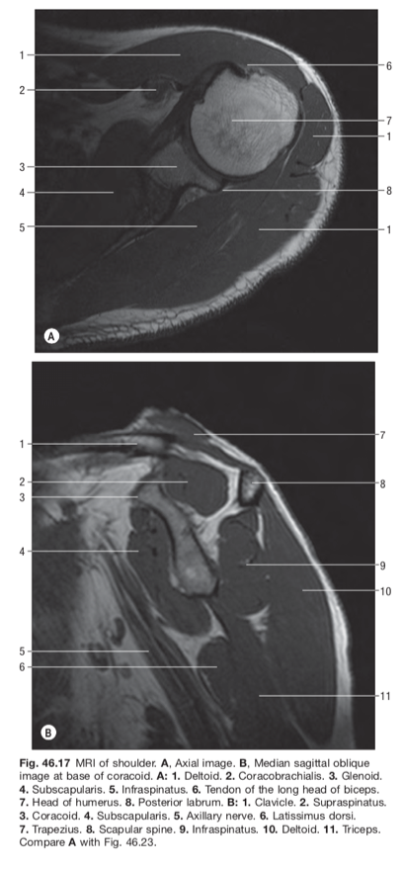
Lecture 19: Axilla, Natalie
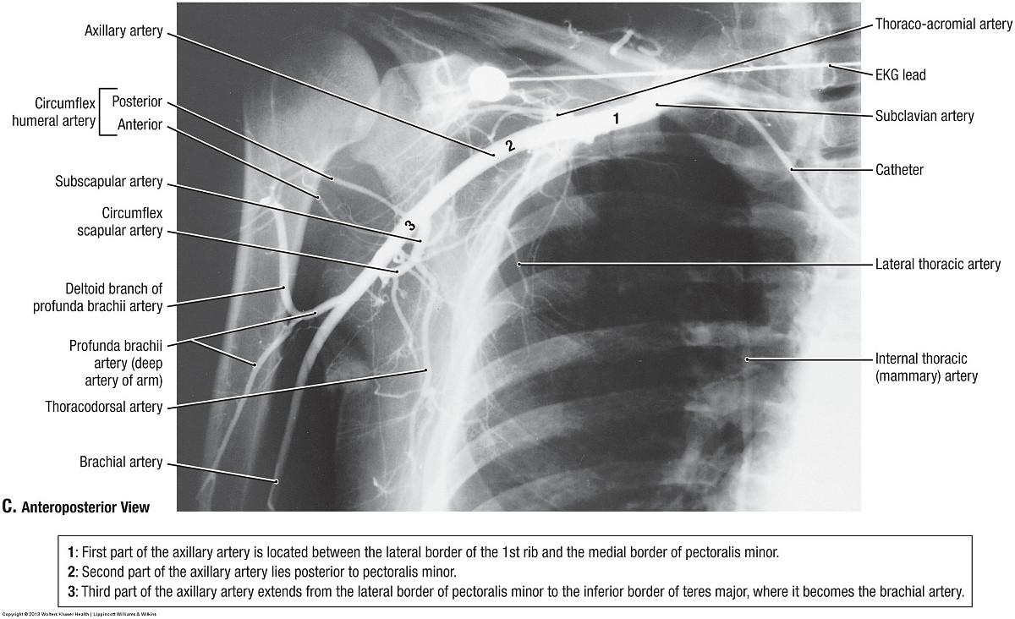

Lecture 22: Forearm, Anna
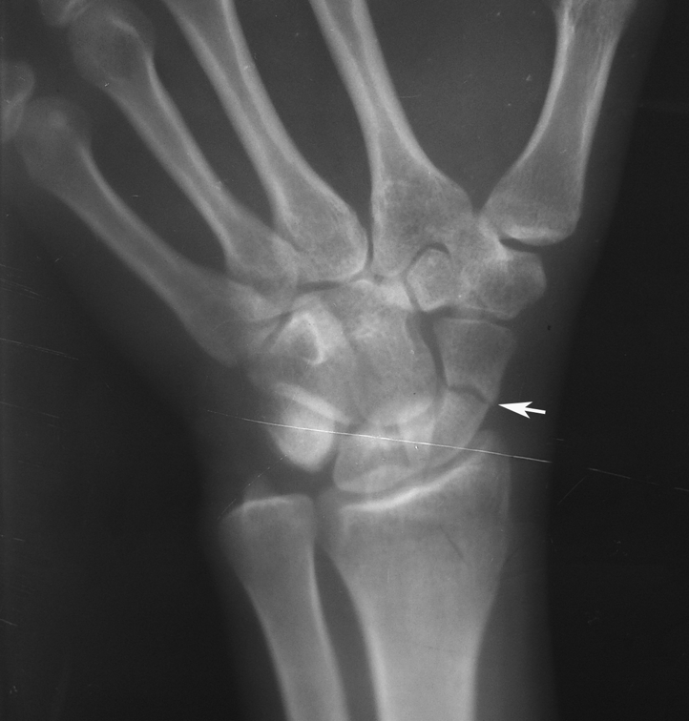

Lecture 28: Middle Mediastinum, Internal Heart, Mary

